Exercise 1: Implementing the Singleton Pattern
Scenario:
You need to ensure that a logging utility class in your application has only one instance throughout the application lifecycle to ensure consistent logging.
Steps:
- Create a New Java Project:
  - Create a new Java project named SingletonPatternExample.
- Define a Singleton Class:
  - Create a class named Logger that has a private static instance of itself.
  - Ensure the constructor of Logger is private.
  - Provide a public static method to get the instance of the Logger class.
- Implement the Singleton Pattern:
  - Write code to ensure that the Logger class follows the Singleton design pattern.
- Test the Singleton Implementation:
  - Create a test class to verify that only one instance of Logger is created and used across the application.
Solution:
public class Logger {

private static volatile Logger instance;

private Logger() {
if (instance != null) {
throw new IllegalStateException("Instance already created.");
}
}

public static Logger getInstance() {
if (instance == null) {
synchronized (Logger.class) {
if (instance == null) {
instance = new Logger();
}
}
}
return instance;
}

public void log(String message) {
System.out.println("[LOG]: " + message);
}
}

public class SingletonTest {
public static void main(String[] args) {
System.out.println("=== Testing Singleton Pattern ===");

// Attempt to get two instances of the Logger
Logger logger1 = Logger.getInstance();
Logger logger2 = Logger.getInstance();

// Use the logger instances
logger1.log("This is the first log message.");
logger2.log("This is the second log message.");

// Verify if both references point to the exact same memory location
System.out.println("\n--- Verification ---");
System.out.println("Logger 1 HashCode: " + logger1.hashCode());
System.out.println("Logger 2 HashCode: " + logger2.hashCode());

if (logger1 == logger2) {
System.out.println("SUCCESS: Both variables reference the SAME instance.");
} else {
System.out.println("FAILURE: Different instances exist.");
}
}
}
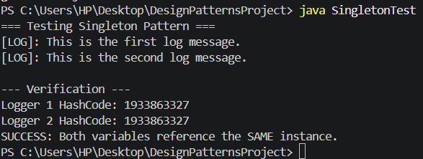
OUTPUT:
Exercise 2: Implementing the Factory Method Pattern
Scenario:
You are developing a document management system that needs to create different types of documents (e.g., Word, PDF, Excel). Use the Factory Method Pattern to achieve this.
Steps:
- Create a New Java Project:
  - Create a new Java project named FactoryMethodPatternExample.
- Define Document Classes:
  - Create interfaces or abstract classes for different document types such as WordDocument, PdfDocument, and ExcelDocument.
- Create Concrete Document Classes:
  - Implement concrete classes for each document type that implements or extends the above interfaces or abstract classes.
- Implement the Factory Method:
  - Create an abstract class DocumentFactory with a method createDocument().
  - Create concrete factory classes for each document type that extends DocumentFactory and implements the createDocument() method.
- Test the Factory Method Implementation:
  - Create a test class to demonstrate the creation of different document types using the factory method.
Solution:
// Step 1: Core Document Interface
interface Document {
void open();
}

// Step 2: Concrete Document Types
class WordDocument implements Document {
@Override
public void open() {
System.out.println("Opening Word Document... Formatting text and layouts.");
}
}

class PdfDocument implements Document {
@Override
public void open() {
System.out.println("Opening PDF Document... Rendering fixed layout page view.");
}
}

class ExcelDocument implements Document {
@Override
public void open() {
System.out.println("Opening Excel Document... Initializing grids and formulas.");
}
}

// Step 3: Abstract Creator (Factory Blueprint)
abstract class DocumentFactory {
// The Factory Method
public abstract Document createDocument();
}

// Step 4: Concrete Factories that make specific documents
class WordDocumentFactory extends DocumentFactory {
@Override
public Document createDocument() {
return new WordDocument();
}
}

class PdfDocumentFactory extends DocumentFactory {
@Override
public Document createDocument() {
return new PdfDocument();
}
}

class ExcelDocumentFactory extends DocumentFactory {
@Override
public Document createDocument() {
return new ExcelDocument();
}
}

public class FactoryMethodTest {
public static void main(String[] args) {
System.out.println("=== Testing Factory Method Pattern ===");

// Create a PDF document using the PDF Factory
DocumentFactory pdfFactory = new PdfDocumentFactory();
Document myPdf = pdfFactory.createDocument();
myPdf.open();

// Create a Word document using the Word Factory
DocumentFactory wordFactory = new WordDocumentFactory();
Document myWord = wordFactory.createDocument();
myWord.open();

// Create an Excel document using the Excel Factory
DocumentFactory excelFactory = new ExcelDocumentFactory();
Document myExcel = excelFactory.createDocument();
myExcel.open();
}
}

OUTPUT:
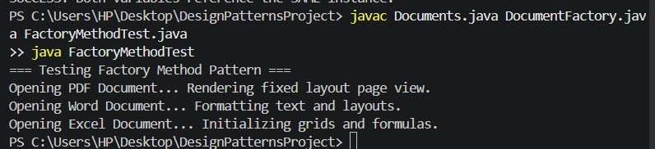
Exercise 3: Implementing the Builder Pattern
Scenario:
You are developing a system to create complex objects such as a Computer with multiple optional parts. Use the Builder Pattern to manage the construction process.
Steps:
- Create a New Java Project:
  - Create a new Java project named BuilderPatternExample.
- Define a Product Class:
  - Create a class Computer with attributes like CPU, RAM, Storage, etc.
- Implement the Builder Class:
  - Create a static nested Builder class inside Computer with methods to set each attribute.
  - Provide a build() method in the Builder class that returns an instance of Computer.
- Implement the Builder Pattern:
  - Ensure that the Computer class has a private constructor that takes the Builder as a parameter.
- Test the Builder Implementation:
  - Create a test class to demonstrate the creation of different configurations of Computer using the Builder pattern.
Solution:
public class Computer {
// Attributes of our complex object
private String CPU;
private String RAM;
private String storage;
private boolean hasGraphicsCard;
private boolean hasBluetooth;

// Step 4: Private constructor that takes the Builder as a parameter
private Computer(Builder builder) {
this.CPU = builder.CPU;
this.RAM = builder.RAM;
this.storage = builder.storage;
this.hasGraphicsCard = builder.hasGraphicsCard;
this.hasBluetooth = builder.hasBluetooth;
}

// Getters to access properties (No setter methods to ensure immutability)
public String getCPU() { return CPU; }
public String getRAM() { return RAM; }
public String getStorage() { return storage; }
public boolean isHasGraphicsCard() { return hasGraphicsCard; }
public boolean isHasBluetooth() { return hasBluetooth; }

@Override
public String toString() {
return "Computer Configuration:\n" +
" - CPU: " + CPU + "\n" +
" - RAM: " + RAM + "\n" +
" - Storage: " + storage + "\n" +
" - Graphics Card: " + (hasGraphicsCard ? "Yes" : "No") + "\n" +
" - Bluetooth: " + (hasBluetooth ? "Yes" : "No") + "\n";
}

// Step 3: Static nested Builder class inside Computer
public static class Builder {
private String CPU;
private String RAM;
private String storage;
private boolean hasGraphicsCard;
private boolean hasBluetooth;

// Setter-like methods that return the Builder instance (enables method chaining)
public Builder setCPU(String CPU) {
this.CPU = CPU;
return this;
}

public Builder setRAM(String RAM) {
this.RAM = RAM;
return this;
}

public Builder setStorage(String storage) {
this.storage = storage;
return this;
}

public Builder setGraphicsCard(boolean hasGraphicsCard) {
this.hasGraphicsCard = hasGraphicsCard;
return this;
}

public Builder setBluetooth(boolean hasBluetooth) {
this.hasBluetooth = hasBluetooth;
return this;
}

public Computer build() {
return new Computer(this);
}
}
}

public class BuilderPatternTest {
public static void main(String[] args) {
System.out.println("=== Testing Builder Pattern ===");

// Configuration 1: High-end Gaming PC (All options set)
Computer gamingPC = new Computer.Builder()
.setCPU("Intel Core i9")
.setRAM("32GB DDR5")
.setStorage("2TB NVMe SSD")
.setGraphicsCard(true)
.setBluetooth(true)
.build(); // Constructs the final object

System.out.println("\n--- Gaming PC ---");
System.out.println(gamingPC);

Computer officePC = new Computer.Builder()
.setCPU("Intel Core i3")
.setRAM("8GB DDR4")
.setStorage("512GB SSD")
// We don't call graphics card or bluetooth, they default to false
.build();

System.out.println("--- Office PC ---");
System.out.println(officePC);
}
}
output:
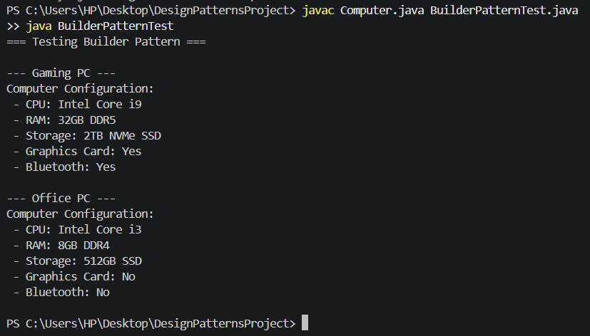
Exercise 4: Implementing the Adapter Pattern
Scenario:
You are developing a payment processing system that needs to integrate with multiple third-party payment gateways with different interfaces. Use the Adapter Pattern to achieve this.
Steps:
- Create a New Java Project:
  - Create a new Java project named AdapterPatternExample.
- Define Target Interface:
  - Create an interface PaymentProcessor with methods like processPayment().
- Implement Adaptee Classes:
  - Create classes for different payment gateways with their own methods.
- Implement the Adapter Class:
  - Create an adapter class for each payment gateway that implements PaymentProcessor and translates the calls to the gateway-specific methods.
- Test the Adapter Implementation:
  - Create a test class to demonstrate the use of different payment gateways through the adapter.
Solution:
// Step 2: Define Target Interface
public interface PaymentProcessor {
void processPayment(double amount);
}

// Step 3: Implement Adaptee Classes (Third-party gateways with unique methods)
class PayPalGateway {
public void makePayment(double dollars) {
System.out.println("Processing $" + dollars + " securely through PayPal API.");
}
}

class StripeGateway {
public void chargeCustomer(double amountInUSD) {
System.out.println("Charging $" + amountInUSD + " via Stripe Elements API.");
}
}

// Step 4: Implement Adapter Classes (Translating calls to match the interface)

// Adapter for PayPal
class PayPalAdapter implements PaymentProcessor {
private PayPalGateway payPalGateway;

public PayPalAdapter(PayPalGateway payPalGateway) {
this.payPalGateway = payPalGateway;
}

@Override
public void processPayment(double amount) {
// Translating processPayment() into makePayment()
payPalGateway.makePayment(amount);
}
}

// Adapter for Stripe
class StripeAdapter implements PaymentProcessor {
private StripeGateway stripeGateway;

public StripeAdapter(StripeGateway stripeGateway) {
this.stripeGateway = stripeGateway;
}

@Override
public void processPayment(double amount) {
// Translating processPayment() into chargeCustomer()
stripeGateway.chargeCustomer(amount);
}
}

// Step 5: Test the Adapter Implementation
public class AdapterPatternTest {
public static void main(String[] args) {
System.out.println("=== Testing Adapter Pattern ===");

// The application interacts ONLY with the standard PaymentProcessor interface
PaymentProcessor paypalProcessor = new PayPalAdapter(new PayPalGateway());
PaymentProcessor stripeProcessor = new StripeAdapter(new StripeGateway());

System.out.println("\n--- Processing via PayPal Adapter ---");
paypalProcessor.processPayment(120.50);

System.out.println("\n--- Processing via Stripe Adapter ---");
stripeProcessor.processPayment(340.00);
}
}

Output:
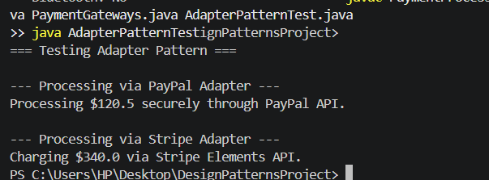
Exercise 5: Implementing the Decorator Pattern
Scenario:
You are developing a notification system where notifications can be sent via multiple channels (e.g., Email, SMS). Use the Decorator Pattern to add functionalities dynamically.
Steps:
- Create a New Java Project:
  - Create a new Java project named DecoratorPatternExample.
- Define Component Interface:
  - Create an interface Notifier with a method send().
- Implement Concrete Component:
  - Create a class EmailNotifier that implements Notifier.
- Implement Decorator Classes:
  - Create abstract decorator class NotifierDecorator that implements Notifier and holds a reference to a Notifier object.
  - Create concrete decorator classes like SMSNotifierDecorator, SlackNotifierDecorator that extend NotifierDecorator.
- Test the Decorator Implementation:
  - Create a test class to demonstrate sending notifications via multiple channels using decorators.
Solution:
// Step 2: Define Component Interface
interface Notifier {
void send(String message);
}

// Step 3: Implement Concrete Component (The core channel)
class EmailNotifier implements Notifier {
@Override
public void send(String message) {
System.out.println("Sending Email: [ " + message + " ]");
}
}

// Step 4: Implement Abstract Decorator Class
abstract class NotifierDecorator implements Notifier {
protected Notifier wrappedNotifier; // Reference to the object being wrapped

public NotifierDecorator(Notifier notifier) {
this.wrappedNotifier = notifier;
}

@Override
public void send(String message) {
wrappedNotifier.send(message); // Pass command to the underlying object
}
}

// Concrete Decorator 1: Adds SMS features on top
class SMSNotifierDecorator extends NotifierDecorator {
public SMSNotifierDecorator(Notifier notifier) {
super(notifier);
}

@Override
public void send(String message) {
super.send(message); // 1. Execute the base notification channels first
sendSMS(message); // 2. Add our specific new behavior
}

private void sendSMS(String message) {
System.out.println("Sending SMS Alert: [ " + message + " ]");
}
}

// Concrete Decorator 2: Adds Slack features on top
class SlackNotifierDecorator extends NotifierDecorator {
public SlackNotifierDecorator(Notifier notifier) {
super(notifier);
}

@Override
public void send(String message) {
super.send(message); // 1. Execute the base notification channels first
sendSlack(message); // 2. Add our specific new behavior
}

private void sendSlack(String message) {
System.out.println("Posting to Slack Channel: [ " + message + " ]");
}
}

// Step 5: Test the Decorator Implementation
public class DecoratorPatternTest {
public static void main(String[] args) {
System.out.println("=== Testing Decorator Pattern ===");

// Scenario A: Standard User (Only wants traditional email notifications)
System.out.println("\n--- Base Notification Channel ---");
Notifier standardAlert = new EmailNotifier();
standardAlert.send("Your weekly report is ready.");

// Scenario B: Enterprise User (Wants Email wrapped with an SMS alert)
System.out.println("\n--- Stacked Channel (Email + SMS) ---");
Notifier structuralAlert = new SMSNotifierDecorator(new EmailNotifier());
structuralAlert.send("Security warning: Password changed!");

// Scenario C: Omnichannel Admin (Wants Email + SMS + Slack combined together)
System.out.println("\n--- Fully Layered Channel (Email + SMS + Slack) ---");
Notifier criticalAlert = new SlackNotifierDecorator(
new SMSNotifierDecorator(
new EmailNotifier()));
criticalAlert.send("CRITICAL: Server database offline!");
}
}

Output:
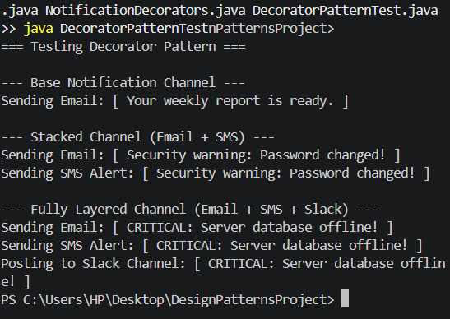

Exercise 6: Implementing the Proxy Pattern
Scenario:
You are developing an image viewer application that loads images from a remote server. Use the Proxy Pattern to add lazy initialization and caching.
Steps:
- Create a New Java Project:
  - Create a new Java project named ProxyPatternExample.
- Define Subject Interface:
  - Create an interface Image with a method display().
- Implement Real Subject Class:
  - Create a class RealImage that implements Image and loads an image from a remote server.
- Implement Proxy Class:
  - Create a class ProxyImage that implements Image and holds a reference to RealImage.
  - Implement lazy initialization and caching in ProxyImage.
- Test the Proxy Implementation:
  - Create a test class to demonstrate the use of ProxyImage to load and display images.
Solution:
// Target Interface
interface Image {
void display();
}

// Concrete Heavy Class
class RealImage implements Image {
private String filename;

public RealImage(String filename) {
this.filename = filename;
loadFromDisk(); // Expensive operation simulated
}

private void loadFromDisk() {
System.out.println("Loading heavy image from disk: " + filename);
}

@Override
public void display() {
System.out.println("Displaying " + filename);
}
}

// Proxy Class
class ProxyImage implements Image {
private RealImage realImage;
private String filename;

public ProxyImage(String filename) {
this.filename = filename;
}

@Override
public void display() {
// Lazy loading: Object created ONLY when display() is called
if (realImage == null) {
realImage = new RealImage(filename);
}
realImage.display();
}
}

public class ProxyPatternTest {
public static void main(String[] args) {
System.out.println("=== Testing Proxy Pattern ===");

Image image = new ProxyImage("high_res_photo.jpg");

// Image hasn't loaded yet! It loads on demand now:
System.out.println("\n--- First Call (Triggers Load) ---");
image.display();

// Second call doesn't load from disk again; it reuses the loaded object
System.out.println("\n--- Second Call (Cached) ---");
image.display();
}
}

Output:
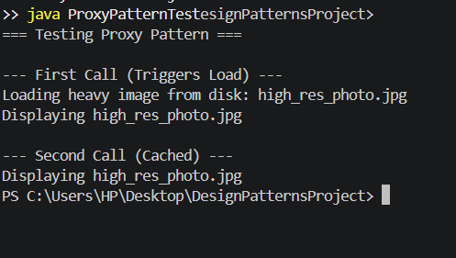
Exercise 7: Implementing the Observer Pattern
Scenario:
You are developing a stock market monitoring application where multiple clients need to be notified whenever stock prices change. Use the Observer Pattern to achieve this.
Steps:
- Create a New Java Project:
  - Create a new Java project named ObserverPatternExample.
- Define Subject Interface:
  - Create an interface Stock with methods to register, deregister, and notify observers.
- Implement Concrete Subject:
  - Create a class StockMarket that implements Stock and maintains a list of observers.
- Define Observer Interface:
  - Create an interface Observer with a method update().
- Implement Concrete Observers:
  - Create classes MobileApp, WebApp that implement Observer.
- Test the Observer Implementation:
  - Create a test class to demonstrate the registration and notification of observers.
Solution:
import java.util.ArrayList;
import java.util.List;

// Observer Interface
interface Observer {
void update(double stockPrice);
}

// Subject / Concrete Publisher
class StockMarket {
private List<Observer> observers = new ArrayList<>();
private double price;

public void register(Observer o) { observers.add(o); }
public void deregister(Observer o) { observers.remove(o); }

public void setPrice(double price) {
this.price = price;
notifyAllObservers(); // Push update instantly
}

private void notifyAllObservers() {
for (Observer o : observers) {
o.update(price);
}
}
}

// Concrete Observer 1
class MobileAppDisplay implements Observer {
@Override
public void update(double stockPrice) {
System.out.println("Mobile App: Stock price updated to $" + stockPrice);
}
}

// Concrete Observer 2
class WebAppDisplay implements Observer {
@Override
public void update(double stockPrice) {
System.out.println("Web Dashboard: Stock price updated to $" + stockPrice);
}
}

public class ObserverPatternTest {
public static void main(String[] args) {
System.out.println("=== Testing Observer Pattern ===");

StockMarket techStock = new StockMarket();
Observer mobile = new MobileAppDisplay();
Observer web = new WebAppDisplay();

techStock.register(mobile);
techStock.register(web);

System.out.println("\n--- Market Price Changes to $150 ---");
techStock.setPrice(150.00);

System.out.println("\n--- Market Price Changes to $155 ---");
techStock.setPrice(155.50);
}
}

Output:
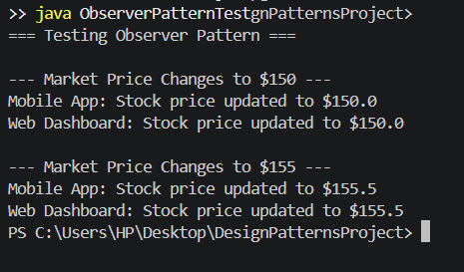
Exercise 8: Implementing the Strategy Pattern
Scenario:
You are developing a payment system where different payment methods (e.g., Credit Card, PayPal) can be selected at runtime. Use the Strategy Pattern to achieve this.
Steps:
- Create a New Java Project:
  - Create a new Java project named StrategyPatternExample.
- Define Strategy Interface:
  - Create an interface PaymentStrategy with a method pay().
- Implement Concrete Strategies:
  - Create classes CreditCardPayment, PayPalPayment that implement PaymentStrategy.
- Implement Context Class:
  - Create a class PaymentContext that holds a reference to PaymentStrategy and a method to execute the strategy.
- Test the Strategy Implementation:
  - Create a test class to demonstrate selecting and using different payment strategies.
Solution:
// Strategy Interface
interface PaymentStrategy {
void pay(double amount);
}

// Concrete Strategy 1
class CreditCardPayment implements PaymentStrategy {
@Override
public void pay(double amount) {
System.out.println("Paid $" + amount + " using Credit Card.");
}
}

// Concrete Strategy 2
class PayPalPayment implements PaymentStrategy {
@Override
public void pay(double amount) {
System.out.println("Paid $" + amount + " using PayPal account.");
}
}

// Context Class (The Cart)
class ShoppingCart {
private PaymentStrategy paymentMethod;

// Change strategy dynamically at runtime
public void setPaymentMethod(PaymentStrategy method) {
this.paymentMethod = method;
}

public void checkout(double amount) {
paymentMethod.pay(amount);
}
}

public class StrategyPatternTest {
public static void main(String[] args) {
System.out.println("=== Testing Strategy Pattern ===");
ShoppingCart cart = new ShoppingCart();

// Select Credit Card
cart.setPaymentMethod(new CreditCardPayment());
cart.checkout(45.99);

// Swap strategy on the fly to PayPal
cart.setPaymentMethod(new PayPalPayment());
cart.checkout(120.00);
}
}

Output:
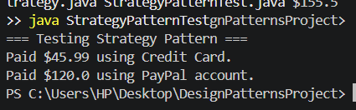
Exercise 9: Implementing the Command Pattern
Scenario: You are developing a home automation system where commands can be issued to turn devices on or off. Use the Command Pattern to achieve this.
Steps:
- Create a New Java Project:
  - Create a new Java project named CommandPatternExample.
- Define Command Interface:
  - Create an interface Command with a method execute().
- Implement Concrete Commands:
  - Create classes LightOnCommand, LightOffCommand that implement Command.
- Implement Invoker Class:
  - Create a class RemoteControl that holds a reference to a Command and a method to execute the command.
- Implement Receiver Class:
  - Create a class Light with methods to turn on and off.
- Test the Command Implementation:
  - Create a test class to demonstrate issuing commands using the RemoteControl.
Solution:
// Command Interface
interface Command {
void execute();
}

// The Receiver (The device doing the actual work)
class Light {
public void turnOn() { System.out.println("The light is ON."); }
public void turnOff() { System.out.println("The light is OFF."); }
}

// Concrete Command 1
class LightOnCommand implements Command {
private Light light;
public LightOnCommand(Light light) { this.light = light; }
@Override public void execute() { light.turnOn(); }
}

// Concrete Command 2
class LightOffCommand implements Command {
private Light light;
public LightOffCommand(Light light) { this.light = light; }
@Override public void execute() { light.turnOff(); }
}

// The Invoker (The physical remote button mechanism)
class RemoteControl {
private Command slot;
public void setCommand(Command command) { this.slot = command; }
public void pressButton() { slot.execute(); }
}

public class CommandPatternTest {
public static void main(String[] args) {
System.out.println("=== Testing Command Pattern ===");

Light livingRoomLight = new Light(); // Receiver
RemoteControl remote = new RemoteControl(); // Invoker

// Program remote button to turn light ON
remote.setCommand(new LightOnCommand(livingRoomLight));
remote.pressButton();

// Re-program same remote button to turn light OFF
remote.setCommand(new LightOffCommand(livingRoomLight));
remote.pressButton();
}
}

Output:
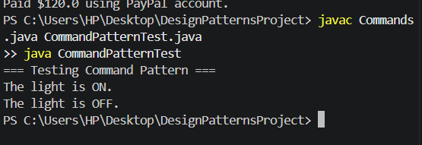

Exercise 10: Implementing the MVC Pattern
Scenario:
You are developing a simple web application for managing student records using the MVC pattern.
Steps:
- Create a New Java Project:
  - Create a new Java project named MVCPatternExample.
- Define Model Class:
  - Create a class Student with attributes like name, id, and grade.
- Define View Class:
  - Create a class StudentView with a method displayStudentDetails().
- Define Controller Class:
  - Create a class StudentController that handles the communication between the model and the view.
- Test the MVC Implementation:
  - Create a main class to demonstrate creating a Student, updating its details using StudentController, and displaying them using StudentView.
Solution:
// 1. THE MODEL (Data Holder)
class Student {
private String name;
private String id;

public String getName() { return name; }
public void setName(String name) { this.name = name; }
public String getId() { return id; }
public void setId(String id) { this.id = id; }
}

// 2. THE VIEW (UI Presentation)
class StudentView {
public void displayStudentDetails(String studentName, String studentId) {
System.out.println("STUDENT DETAILS PANEL:");
System.out.println("Name: " + studentName);
System.out.println("ID: " + studentId);
}
}

// 3. THE CONTROLLER (The Mediator bridge)
class StudentController {
private Student model;
private StudentView view;

public StudentController(Student model, StudentView view) {
this.model = model;
this.view = view;
}

public void setStudentName(String name) { model.setName(name); }
public void updateView() {
view.displayStudentDetails(model.getName(), model.getId());
}
}

public class MvcPatternTest {
public static void main(String[] args) {
System.out.println("=== Testing MVC Pattern ===\n");

// Set up clean database data model
Student model = new Student();
model.setName("Alice");
model.setId("BME605B-01");

StudentView view = new StudentView();
StudentController controller = new StudentController(model, view);

// Show starting structure
controller.updateView();

// Mutate/Change name via Controller interface channel
System.out.println("\n--- Updating Name via Controller ---");
controller.setStudentName("Alice Smith");
controller.updateView();
}
}

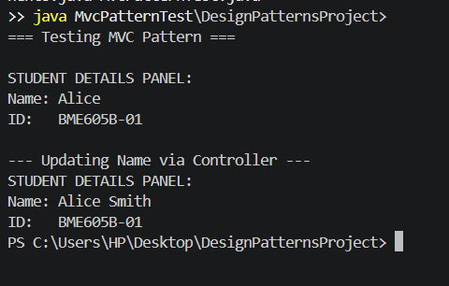

Exercise 11: Implementing Dependency Injection
Scenario:
You are developing a customer management application where the service class depends on a repository class. Use Dependency Injection to manage these dependencies.
Steps:
- Create a New Java Project:
  - Create a new Java project named DependencyInjectionExample.
- Define Repository Interface:
  - Create an interface CustomerRepository with methods like findCustomerById().
- Implement Concrete Repository:
  - Create a class CustomerRepositoryImpl that implements CustomerRepository.
- Define Service Class:
  - Create a class CustomerService that depends on CustomerRepository.
- Implement Dependency Injection:
  - Use constructor injection to inject CustomerRepository into CustomerService.
- Test the Dependency Injection Implementation:
  - Create a main class to demonstrate creating a CustomerService with CustomerRepositoryImpl and using it to find a customer.
Solution:
// Repository Interface
interface CustomerRepository {
String findCustomer(int id);
}

// Concrete Repository Driver Implementation
class CustomerRepositoryImpl implements CustomerRepository {
@Override
public String findCustomer(int id) {
return "Customer Database Match #ID: " + id + " [Active Profile]";
}
}

// Service Class needing Repository
class CustomerService {
private final CustomerRepository repository;

// CONSTRUCTOR INJECTION: Dependency is cleanly supplied from outside
public CustomerService(CustomerRepository repository) {
this.repository = repository;
}

public void printCustomerDetails(int id) {
String result = repository.findCustomer(id);
System.out.println("Service layer response: " + result);
}
}

public class DependencyInjectionTest {
public static void main(String[] args) {
System.out.println("=== Testing Dependency Injection ===");

// Step 1: Instantiate the data repository engine piece
CustomerRepository repoDriver = new CustomerRepositoryImpl();

// Step 2: Inject that engine straight into the service initialization path
CustomerService service = new CustomerService(repoDriver);

// Step 3: Run target utility
service.printCustomerDetails(101);
}
}

Output:
